Experiment 1: Determination of free CO₂ using N/50 NaCO₃

1) What is the Indicator used in this reaction?
Ans: Phenolphthalein.

2) What is the End-point of this reaction?
Ans: Colourless to Pink.

3) What is Normality. What is its S.I unit?
Ans: The number of gram or mole equivalents of solute present in one litre of a solution.
The SI unit for normality is moles per liter (mol/L). Its denoted by “N”.

4) What is strength of a solution?
Ans: The strength of the solution is defined as the amount of solute in gram dissolved per liter of the solution.
S.I unit: mg/L or ppm.

5) What type of titration is performed in this experiment?
Ans: Acid-Base titration.

6) Draw the structure of Phenolphthalein.

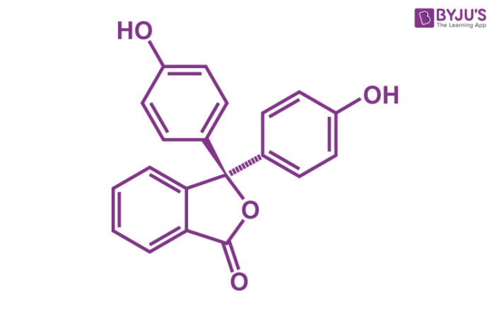

7) Is CO₂ Acidic or Basic?
Ans: Acidic.

8) What do you mean by free CO₂ in water?
Ans: "Free CO2 in water" refers to the dissolved carbon dioxide gas present in a water sample that is not chemically bound or in equilibrium with other dissolved species. When carbon dioxide (CO2) is exposed to water, it can dissolve and form carbonic acid (H2CO3), which can further dissociate into bicarbonate ions (HCO3-) and hydrogen ions (H+). The term "free CO2" specifically refers to the dissolved CO2 that remains in its gaseous form in the water.
Experiment 2: Determination of Moisture in Soil.

1) What is the use of Desiccator?
Ans: A desiccator is a specialized piece of laboratory equipment used for the drying or preservation of moisture-sensitive substances. It consists of a sealed container made of glass or plastic with a removable lid and an airtight seal. The interior of the desiccator contains a drying agent such as silica gel or anhydrous CaCl₂ .

2) What type of method is used for measuring the content of water in soil?
Ans: Gravimetric.

3) What is the temperature to be set in the Oven during experiment?
Ans: 105º C.

Experiment 3: Determination of Ammonia NH₃ in water using N/50 H₂SO₄

1) What form ammonia is present in water?
Ans: Ammonium Hydroxide (NH₄OH).

2) What type of titration is performed during the experiment?
Ans: Acid-Base.

3) What is the indicator used in this reaction?
Ans: Methyl-Red.

4) What is the End-point of this reaction?
Ans: Yellow to Red.

5) Draw the structure of methyl red.
Ans:
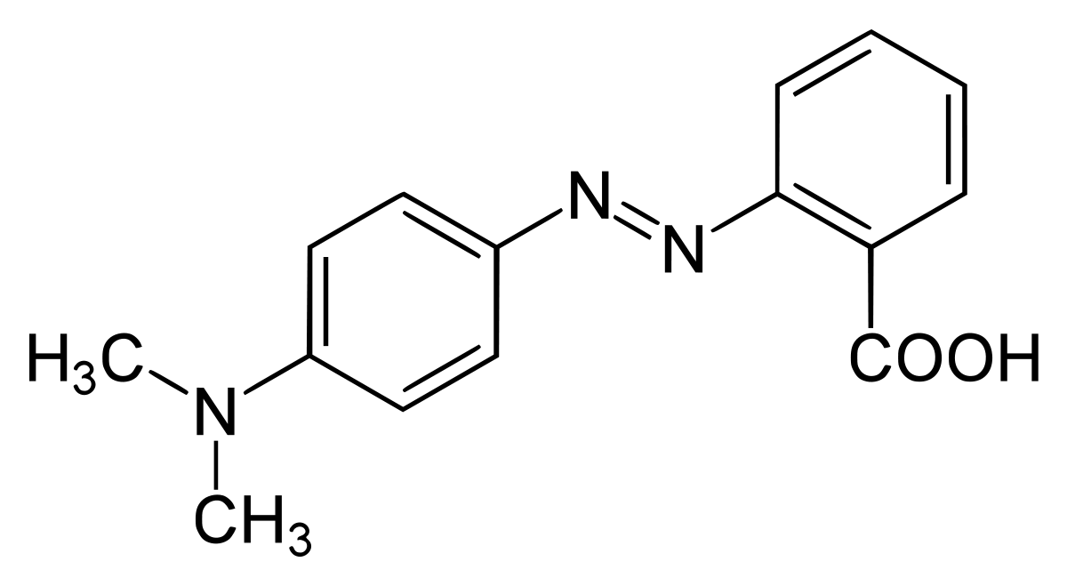

Experiment 4: Determination TDS in water.

1) What is TDS (Total Dissolved Solids)?
Ans: Dissolved solids refers to any minerals, salts, cation or anions dissolved in water, which varies between 20-1000 ppm.

2) What is the temperature to be set in oven for this experiment?
Ans: 180º-190º C.

Experiment 5: TRC in Water using N/50 Na₂S₂O₃ and Conc. HCL.

1) What kind of titration is performed in this experiment?
Ans Idometric as I₂ is liberated.

2) How is residual chlorine estimated?
Ans: Residual Chlorine is estimated by oxidation of KI with RC with liberation of I₂.

3) What is indicator used?
Ans: Starch. Blue-Black.

4) Colours shown: Brown to straw yellow to blue-black to colourless.

5) Why we don’t use pipette for this experiment.
Ans: Because chlorine vapours are harmful so the solution is not sucked into pipette. Instead Measuring cylinder is used.

6) What is residual Chlorine?
Ans: Residual chlorine refers to the amount of chlorine that remains in water or a solution after disinfection or chlorination processes have occurred. Chlorine is widely used as a disinfectant in water treatment to kill or inactivate harmful microorganisms, including bacteria, viruses, and parasites.

Experiment 6: Dissolved Oxygen in water using N/40 Na₂S₂O₃ and Conc. H₂SO_{4.}

1) What are the oxygen carrier in this experiment?
Ans: MnSO_{2.}

2) What kind of titration is performed in this experiment?
Ans Idometric as I₂ is liberated.

3) Why we check oxygen levels for pollution?
Ans: Oxygen itself is not a pollution, but its absence is an indicator of several types of pollution.

4) What is azide in Alkaline Iodide Azide?
Ans: N₃⁻.

5) What is used remove nitrites (NO₂⁻)?
Ans: Sodium Azide.

6) Draw structure of C₆H₁₀O₅ (Starch)? What is its colour?
Ans: Blue-Black colour.
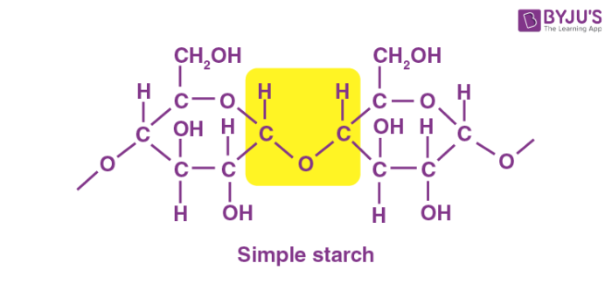

7) Why we didn’t add starch indicator at the beginning of the reaction?
Ans: Because it will reach will other reagents.

8) In what state oxygen is present in water?
Ans: Oxygen is present in its molecular form. So iodine is not capable of reacting.

9) What is the difference between end point and equivalence point?

10) What is Hypo solution?
Ans: Na₂S₂O₃.
Experiment 7 and 8: Determination of PH and Conductivity of water.

1) What is the S.I unit of conductivity?
Ans: Siemens per meter.

